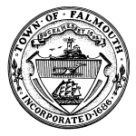
FALMOUTH VETERANS’ COUNCIL
59 TOWN HALL SQUARE, FALMOUTH, MA. 02540
(508) 495-7450 FAX (508) 495-7451

Veterans’ Council Meeting Agenda

Date: January 14, 2026

Time: 4:00 p.m.

Location: CIVIL DEFENSE ROOM, TOWN HALL

- Open Discussion:

Julie Cadogan
Julie Cadogan
For, Falmouth Veterans’ Council

The Council reserves the right to take agenda items out of order.

THE PUBLIC IS WELCOME TO ATTEND

