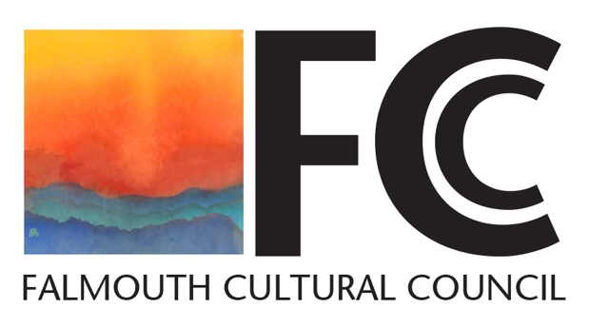

Falmouth Cultural Council
AGENDA
Tuesday, February 17, 2026
7:00 PM
Select Board Meeting Room
Town Hall

- Establish a Quorum
- Approve Minutes of the January 20, 2026 FCC Meeting
- Treasurer’s Report: Music at the Table, Grant Awards, and Reserve Funds
- FY26 Grantee Liaisons’ Update: Outstanding Grant Agreement, Confirmed Schedule of Events/Logos and Credit Language, and Photos Needed for Reception Slideshow
- Cultural Council & Possible Arts/Cultural Programming for the 250 Anniversary of the American Revolution
- Planning for Grantee Spring Reception: Confirmed for Saturday, April 25, 2 to 4 PM, Falmouth Museums on the Green
- Old Business
- New Business
- Motion to Adjourn

