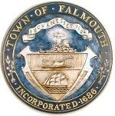
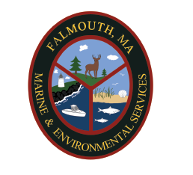
TOWN OF FALMOUTH
NITROGEN CONTROL (FERTILIZER)
TOWN CODE CHAPTER 237

PURPOSE: To conserve resources and protect our environment by regulating the outdoor application of nitrogen and to reduce the overall amount of excess nitrogen entering the Town’s Resource Areas as defined in the Wetlands Protection By-Law (Chapter 235, Section 2) and regulations.

APPLICABILITY: The by-law applies to and regulates ALL applications of nitrogen through fertilizer within the Town of Falmouth. (This includes private or commercial applications)

ALL APPLICATIONS OF NITROGEN THROUGH FERTILZER SHALL ADHERE TO THE FOLLOWING:

- Fertilizer (nitrogen) is prohibited from October 16th to April 14th annually.
- The application of Fertilizer (nitrogen) is prohibited within 100 feet of Resource Areas as defined in Falmouth’s Wetlands regulations FWR 10.02(1)(a) through (d).
- Any fertilizer applied, spilled, and/or deposited on any impervious surface must be immediately and completely removed and contained and either legally applied or returned to an appropriate storage container.
- Fertilizer may not be applied directly before or during a heavy rain event.

EXEMPTIONS:

- Application for agriculture or horticulture.
- Application of fertilizer to golf courses (some restrictions apply, see by-law)
- Application of nitrogen to gardens, trees, shrubs and indoor applications including greenhouses.
- Application of nitrogen for the establishment of NEW vegetation in the first growing season or repairing of turf after substantial damage.
- Yard waste compost or other similar materials that are primarily organic in nature and are applied to improve the physical condition of the soil.

RECOMMENDATIONS:

The Town strongly recommends that nitrogen be applied at the LOWEST rate necessary. Any single application of nitrogen should not exceed 0.5 pounds of nitrogen per 1,000 square feet, and annual aggregate total application of nitrogen should not exceed 1.0 pounds per 1,000 square feet.
In addition, it is recommended you use organic slow-release nitrogen that is also water-insoluble form.

ADDITIONAL INFORMATION: For additional information please see the Falmouth Town Code Chapter 237. You may also contact the Marine & Environmental Services Department. Violations may be reported to MES at 508-457-2550.

