Falmouth Human Services: Five Decades of Compassion and Community Support

By Michael Bihari, MD/Human Services Co-chair

This year marks the 50th anniversary of one of Falmouth’s most vital town departments: Falmouth Human Services. Since 1975, it has served as a cornerstone of the town’s extensive human services network. In a community with a year-round population just under 35,000—nearly half of whom are older adults—accessible, responsive social services are essential for helping people thrive and age in place.

At the heart of this effort is Falmouth Human Services, a trusted connector within a broad network of community support, including the Falmouth Service Center, Belonging to Each Other, the Falmouth Police Department, Housing Assistance Corporation, Neighborhood Falmouth, the Falmouth Senior Center, the Community Health Center, and the faith community, among others. Together, these groups ensure no one in crisis is left behind.

A History Rooted in Caring for the Community
Falmouth’s commitment to social support dates back to 1970, when a grassroots coalition formed the Falmouth Community Council and successfully petitioned Town Meeting to fund a trial program with a professional social worker. That program’s success led to the creation of a formal Human Services Committee in 1975 to advise town officials on community needs and recommend solutions, including advocating for supportive policies and programs.

In 1983, Peter D. Kirwin was appointed director and led Human Services for 25 years, transforming it into a professionally staffed municipal department. Under his leadership, Falmouth Human Services launched more than 150 programs, many of which later became self-sustaining and are now run by other town departments or nonprofit partners—a notable example is the Falmouth Service Center.

How Falmouth Human Services Helps the Town Today
The department employs four full time licensed clinical social workers, and one part-time Portuguese-speaking clinician to help meet the needs of the town’s growing Brazilian community. Its mission is clear: “to strengthen the Falmouth community by offering a wide range of social services, advocacy, and connections to care that support and empower residents.”

Counseling and Support
In FY25, Falmouth Human Services staff provided a total of 3,505 encounters to 244 residents, encompassing individual and group counseling sessions, case management, and outreach visits. Support groups were offered to meet a range of needs, including sessions for women’s wellness, LGBTQIA+ seniors, and individuals experiencing grief. A dedicated group for men transitioning out of homelessness was provided through a partnership with Belonging to Each Other. Additionally, a department social worker facilitates a grief support group for parents, guardians, and caregivers who have lost a child to a substance use disorder.

Language Access and Equity
To meet the growing needs of Falmouth’s Portuguese-speaking population, the department hired a bilingual clinician. In just her first four months, she conducted 55 consultations, primarily serving Brazilian residents. As concerns around deportation and immigration-related legal issues grow, demand for these culturally responsive services is expected to increase significantly.

Collaboration and Community Integration
Falmouth Human Services maintains active collaboration with the public schools, public safety officials, community groups, and faith-based organizations. A department social worker serves as a clinical supervisor to an MSW intern with the Pathways Program, a mentorship initiative through Volunteers in Public Schools (VIPS) for students at risk of not completing high school. The department also convenes the Essential Services Network, a coalition of social service agencies and the Falmouth Police Department, to coordinate care for individuals experiencing homelessness. During the winter months, Human Services works closely with partners—including Belonging to Each Other, Falmouth Service Center, Housing Assistance Corporation, and Duffy Health Center—to provide temporary motel housing for unhoused residents during dangerously cold weather.

Referrals and Accessibility
In the past year, the department responded to more than 1,200 requests for help. Most inquiries were related to housing and homelessness, mental health, aging services, and financial hardship. To streamline access to support, several community partners maintain regular office hours at the Human Services building. These include a case manager from the Housing Assistance Corporation, a health navigator from Community Action Committee of Cape Cod and Islands, and a volunteer attorney from the Immigration Resource Center.

Managing Local Resources
Falmouth Human Services also oversees more than $100,000 in grant funding to support targeted local initiatives. Current priorities include homelessness prevention and outreach, expanding access to high-quality affordable childcare, and providing grief support groups in the Falmouth Public Schools. These grant-funded programs help expand the region’s capacity to deliver responsive, locally driven solutions to pressing social needs.

Collaboration = Success
Some of Human Services greatest success stories are the result of close collaboration with community partners. Partnerships that over the years have helped many Falmouth residents facing overwhelming challenges such as mental illness, homelessness, poverty, grief, trauma, and isolation—often all at once. What makes the department’s work possible is the ability to bring together the right mix of agencies—from state and regional systems to local providers—to move someone from crisis and despair to safety, stability, and, ultimately, a more dignified life.

One example stands out. Several years ago, the department helped stabilize a homeless resident living with severe mental illness. Many local providers and business owners knew this individual and shared deep concern, but it seemed as though the person was falling through the cracks. It took months of behind-the-scenes coordination—with hospitals, police, housing agencies, and the state mental health system—to plan a thoughtful, compassionate intervention. Falmouth Human Services served as both convener and coordinator, but the most important part was building trust with this person over time. Many years later, this individual is still housed, still healthy, still in touch with Human Services staff, and is a joyful, valued member of the Falmouth community. This is only one of many stories where the department and its community partners were able to step in and truly change the trajectory of someone’s life for the better.

Looking Ahead
Celebrating 50 years is not just about looking back—it’s a call to action. Falmouth faces serious challenges: a lack of affordable housing, growing mental health needs among youth, a rapidly aging population, and a shortage of both primary and behavioral health providers. Add to that a volatile national climate, and the importance of local, community-driven care has never been greater. These are not problems with quick fixes—they require sustained investment and community-wide cooperation.

Thanks to the dedication of town staff, volunteers, and nonprofit leaders, Falmouth has built a model of caring rooted in compassion, collaboration, and persistence. As the town looks to the future, one thing remains clear: when we take care of each other, Falmouth is stronger.

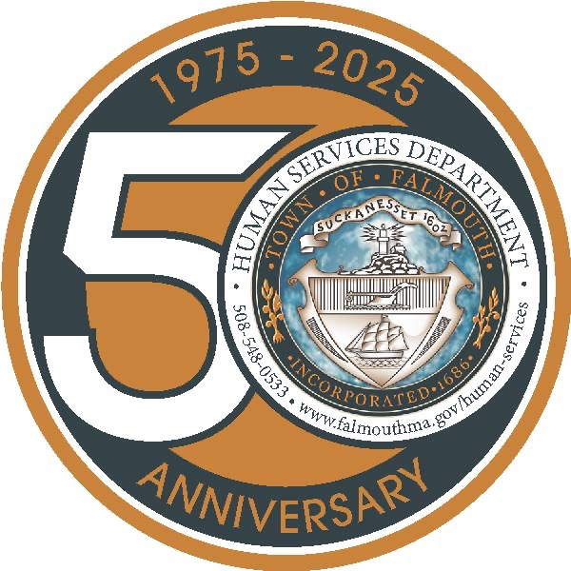
Falmouth Human Services is located at 744 Main Street in Falmouth. You can contact them at 508-548-0533 and info.humanservices@falmouthma.gov. Suzie Hauptmann, MSW, LICSW, is the current director.

